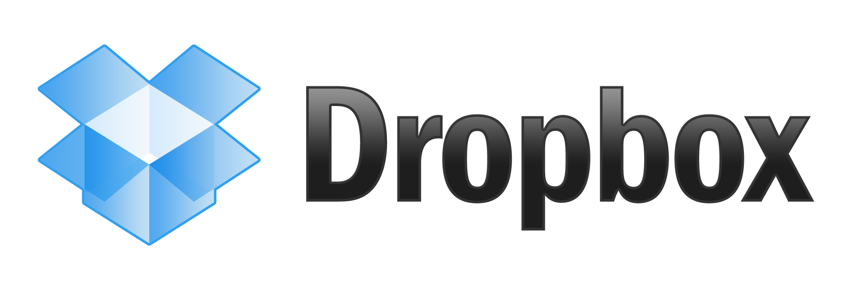

Just as Facebook revolutionized the way we connect with people around you, Dropbox dramatically transformed the way we share files. For users it eliminates the need to email pictures to yourself, a way to access files from anywhere, collaborate as a team, and as a someone who has a customer doing this – push changes across servers around the globe among other things. Will Dropbox have the same fate as other fast-growing tech companies that are now “no longer cool?” Unlike the famous flops in the last decade, Dropbox has one advantage – it doesn’t require a massive audience to still be found useful unlike companies like Facebook where people would not use their service if they didn’t have friends using it. Their target market is very broad allowing for their reach to only increase beyond what they already have with the consumer Dropbox service and Dropbox for Teams, for businesses. Dropbox got their start in 2008, amassing [over 100 million users in under four years](https://blog.dropbox.com/2012/11/thanks-a-hundred-million/). To put that into perspective that’s a user signing up every second for four years, or an even weirder way – just shy of the amount of times your heart beats for four years straight. Dropbox has taken the Google approach to everything about their business. They have aspired to build a staff full of energetic, young, and quirky individuals with the idea to come and go as you please at work, free meals, and the ability to play videogames at work. This free-flowing spirit, one that is a favorite for Silicon Valley companies, has allowed them to pull executives from [Apple, Salesforce, Google,](http://venturebeat.com/2012/12/21/dropbox-hires-sales-execs-from-salesforce-and-apple-to-bolster-its-enterprise-push/) and many other very well recognized established companies. What does that mean though for the user? That means they have individuals working for them to find ways that Dropbox can integrate in almost every business. From the mom and pop cake company that can simply take a photo of the new cake they made on their iPhone and it’s instantaneously synced to the iPad that has example cake photos for potential clients in the storefront, a customer of mine who uses Dropbox to sync settings across their servers world-wide, having access to my class notes on the go no matter where I am or what devices I have on me, to allowing myself have our most up-to-date pricing and information sheets for customers to view at any moment. Dropbox has dramatically improved the productivity and accuracy for my employer, allowing decisions to be made by our headquarters in Chicago and disseminated through the sales and support staff through frequently referenced documents. Despite Dropbox having fad-like growth, I believe that since Dropbox has a use for every individual and business that it will continue to be a trend to use.